Breakfast of Champions

Stan was hungry, hungry for some mancream. He changed into his muscle shirt and pussy fucker trunks and snapped on his cock ring. Pulling on his 14 oz Everlast boxing gloves. He was now ready for some cock boxing action.

Lubing his gloves with cocoa butter, Stan grabbed his dick and starting pulling. His Manmuscle quickly boned up into his usual pussy punching hardness. He could feel the waves of

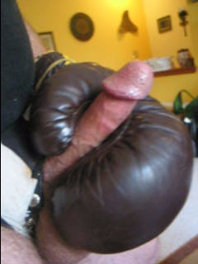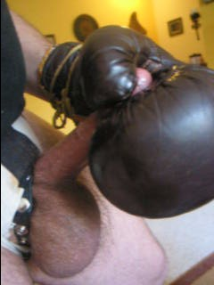

His balls contricted by the tight cock ring bounced like a spend bag as his boxing gloved fist rapidly milked his manmuscle for some cream.

Before long, he started panting and moaning as he became aware of only the pounding of this manmuscle into his well lubbed boxing glove. Sometimes he was aware of his pussy puncher. It was like when he slammed his hard rod into a moist cunt, the friction as he powered his man muscle into her. His huge head would plow its way up her channel, she would close in on the rest of his rod. Then he’d pull out a bit and drive in deeper.

At other times he was aware of his fist. His fist was inside a boxing glove. His fist tightened as he stroked. His fist felt wonderful inside the tightness of a boxing glove. A boxing gloved fist could do wonders to another guy’s face and body. Bam – a right cross. Ping – Ping – Ping – a series of jabs to the face. Pow – an upper cut to deliver a KO. KO? It was time for a cum KO.

He panted loudly as a wad of man cream pushed its way up from this huge balls and burst past his swollen head. A river of cum flowed across his boxing gloves fists as he tried to capture each drop on his boxing gloved hands. Breathing heavily, Stan finally smiled. It was time to eat.

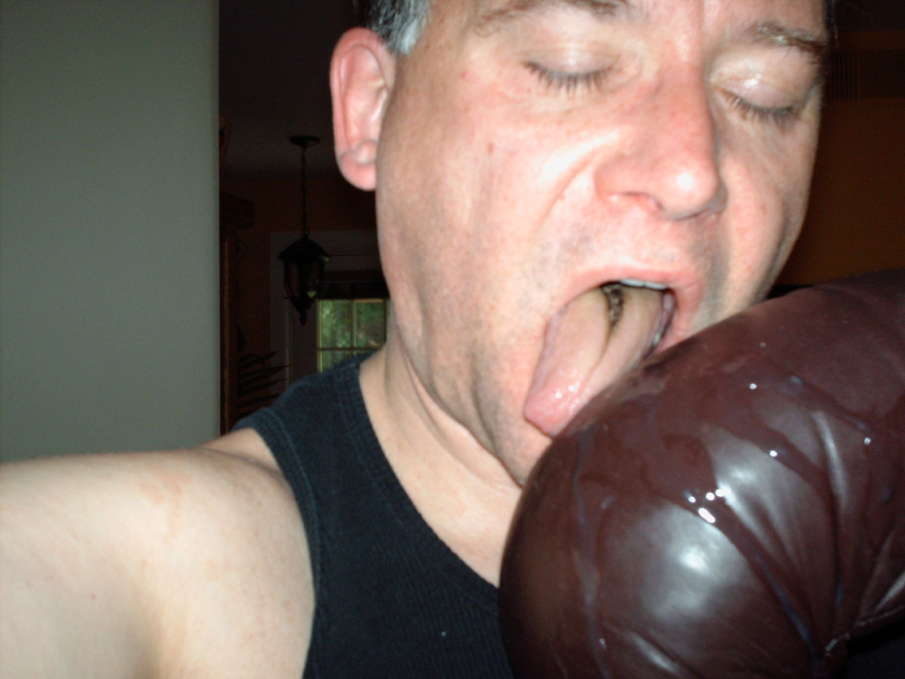

Stan worked quickly to ock up the still flowing man cream on his boxing gloves. He licked up the wads and the rivulets. His tongue ran across the surface of the boxing gloves. The saltiness and sweetness of cum tasted like fine cognac as it went down his throat. A little bite but so sweet. He breathed in the scent of cum. Vintage.

Stan licked every drop of cum off his gloves. Those gloves that were used to batter men around a ring – covered with sweat and tears. He licked up the remnants of long forgotten boxing matches between un-named opponents. But today, he licked up his breakfast.
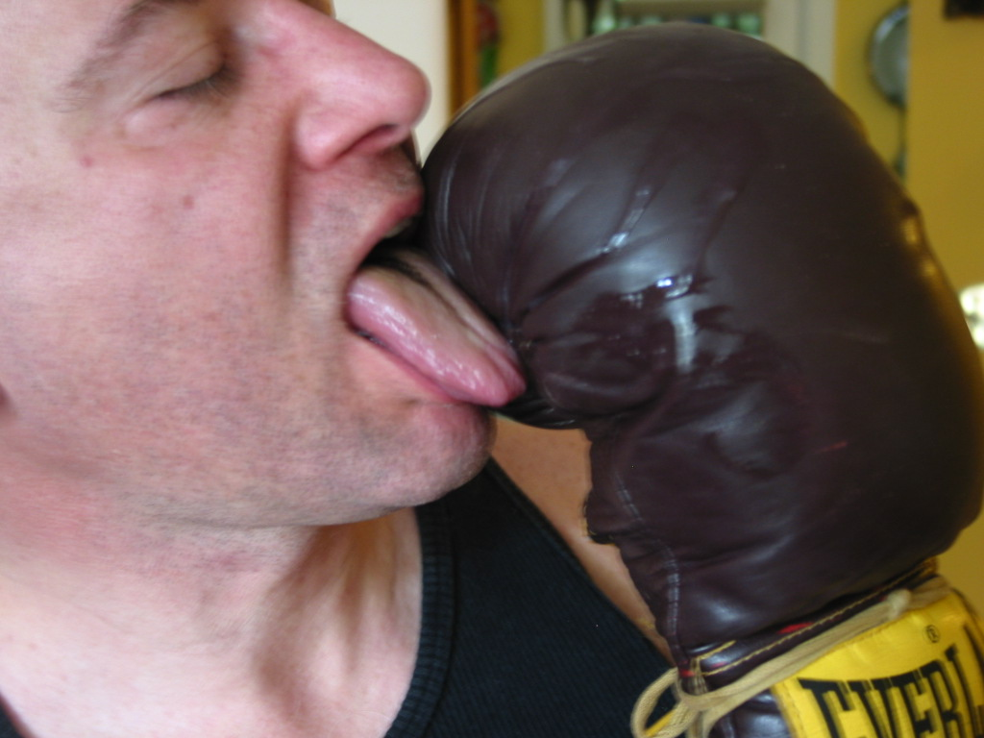

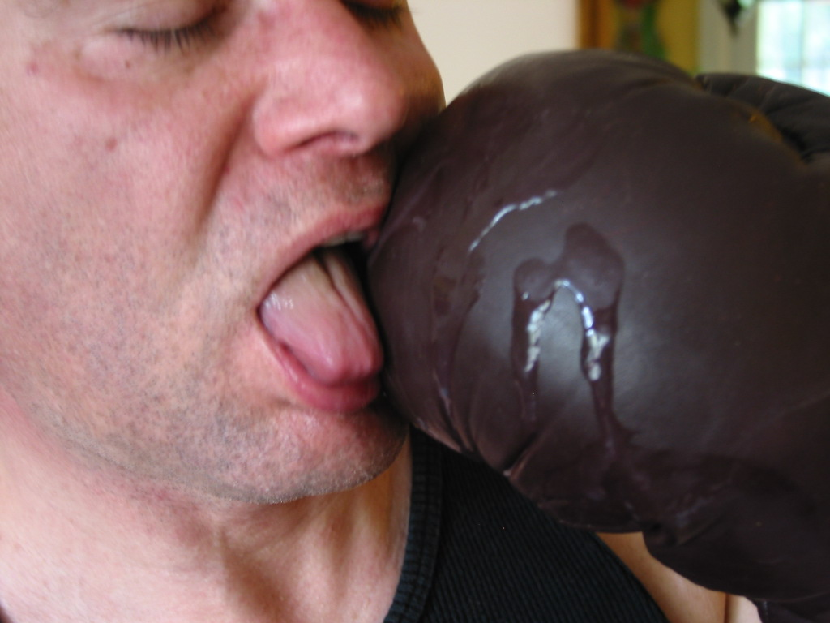

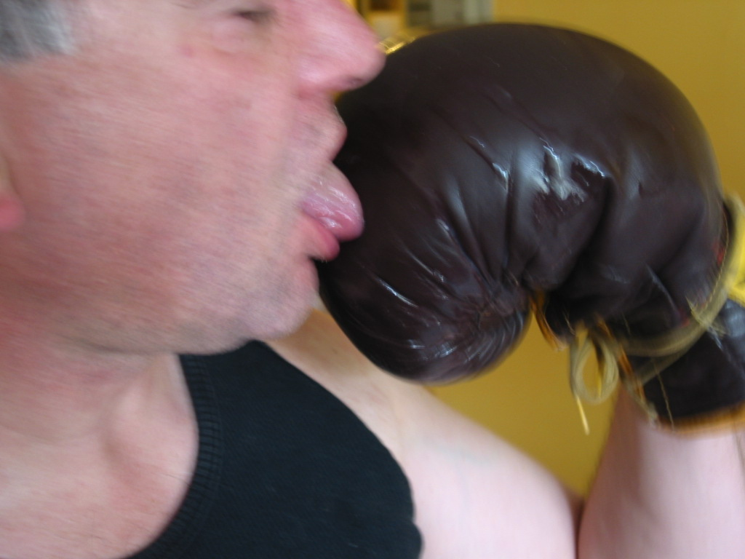

Stan cleaned off the gloves meticulously. Ever fold of leather contained the creamy white nectar he craved. As he swallowed his cum, a wave of power dropped into his stomach. He felt it radiate from his guts to his arms and into his fists. Like Popeye who had swallowed spinach, the cum was coming back in the form of new waves of man power. Like Popeye, the sense of power needed a display of power. Stan started flexing his biceps which bounced up and down as he flexed. Each time he flexed, his arms felt harder and stronger. His boxing gloved fists felt like jackhammers, ready to pound a hole in the nearest wall. Stan flexed as he finished his breakfast by licking the last drops off his gloves.

Stan also felt the power pour into his man muscle. It was now hard again. Tasting cum always made Stan hard. He flexed again as he finished licking his boxing gloved fist. “What muscles!” he chuckled. Kissing his boxing gloved fist, he flexed a final time before grabbing his now fully erect manmuscle with his other boxing gloved fists.

Stan stood in front of a low table onto which he had laid out his collection of boxing gloves. Time for a boxing glove bukkake. Time to cook up a second helping.

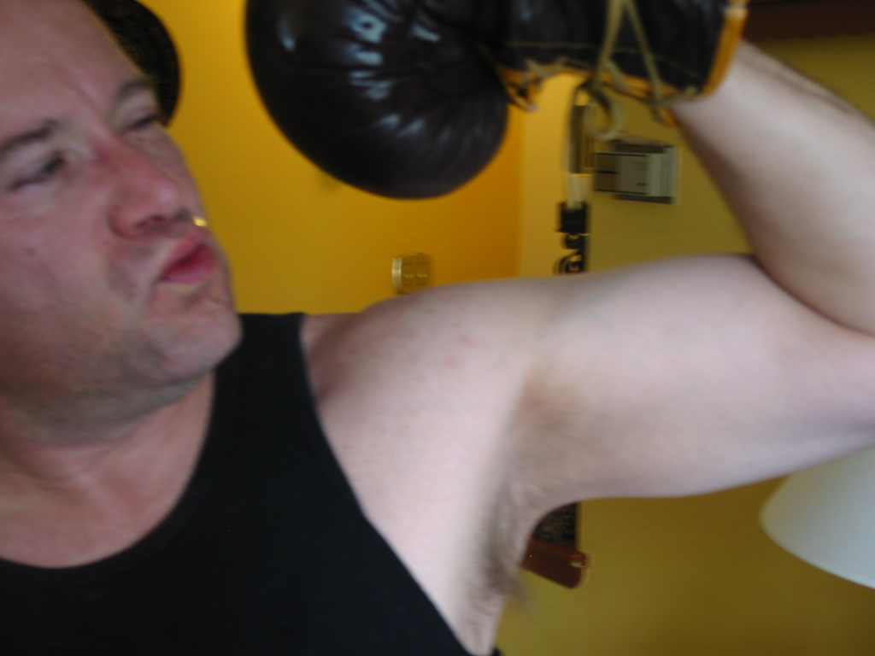

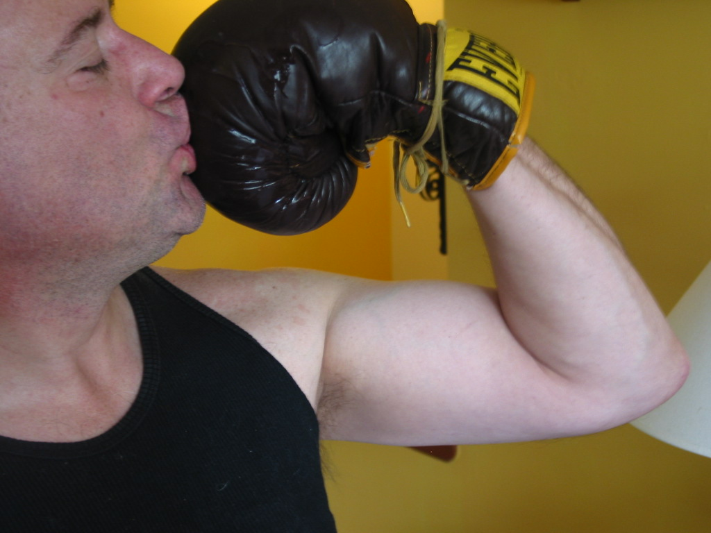

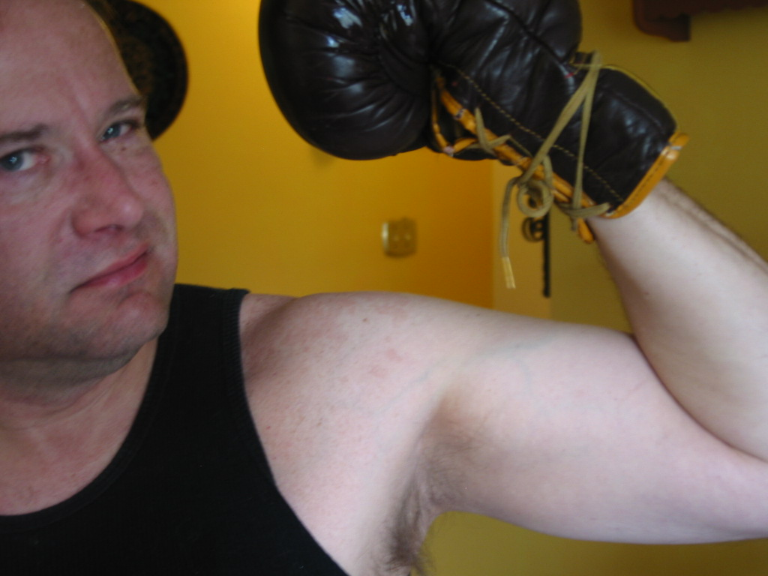

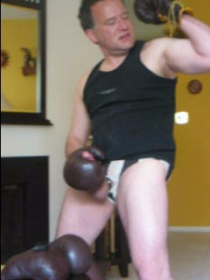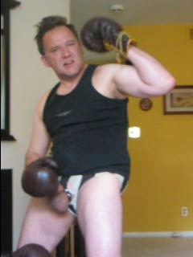

Stan’s awareness of renewed strength and power migrated from his boxing gloved flexed biceps back to his boxing gloved fist pulling his hard cock.
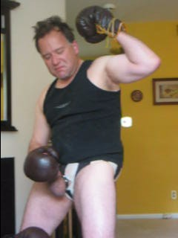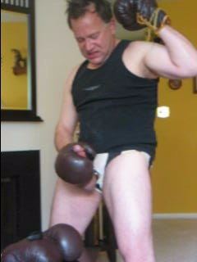

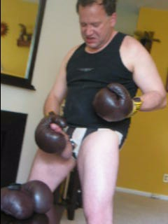

His cock was so hard and erect that only short quick strokes were possible. Stan’s huge balls bounced as he worked on his big manmuscle. Soon he was only aware of the sensation of his boxing gloved fist stroking his mighty pussy puncher. He face contorted as he worked to pull off the Herculean feat of shooting again. It was like getting into the ring in round ten and powering his opponent into the ropes with a power packed cross. It was like racing in for the kill with upper cut after upper cut to a defenseless opponent. It was like driving his cock deep into a pussy and then driving in further.

Then at last, a river of cum spewed from the tip of his dick onto the boxing gloves waiting below. Stan grunted loudly as the flow began and then started shouting as his whole being contracted with each wad being pushed out into the open.

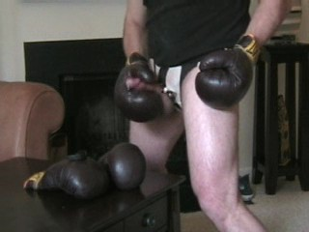

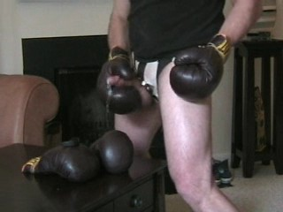

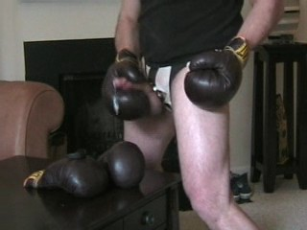

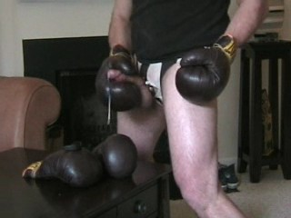

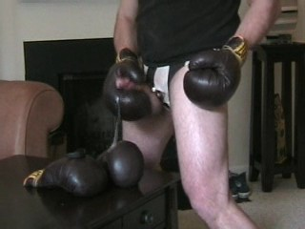

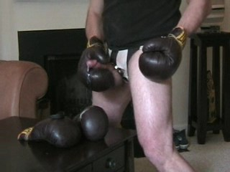

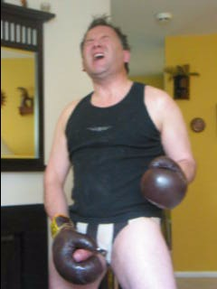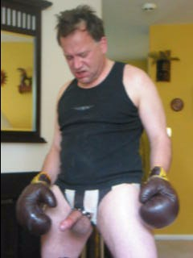

Stan roared as the last wave crushed through him as his balls emptied. Exhausted and exhilarated, he dropped his fists.

As soon as he regained awareness, Stan acted fast to catch the second course of his breakfast. He pulled of the gloves he was wearing and pulled on the cum covered gloves.

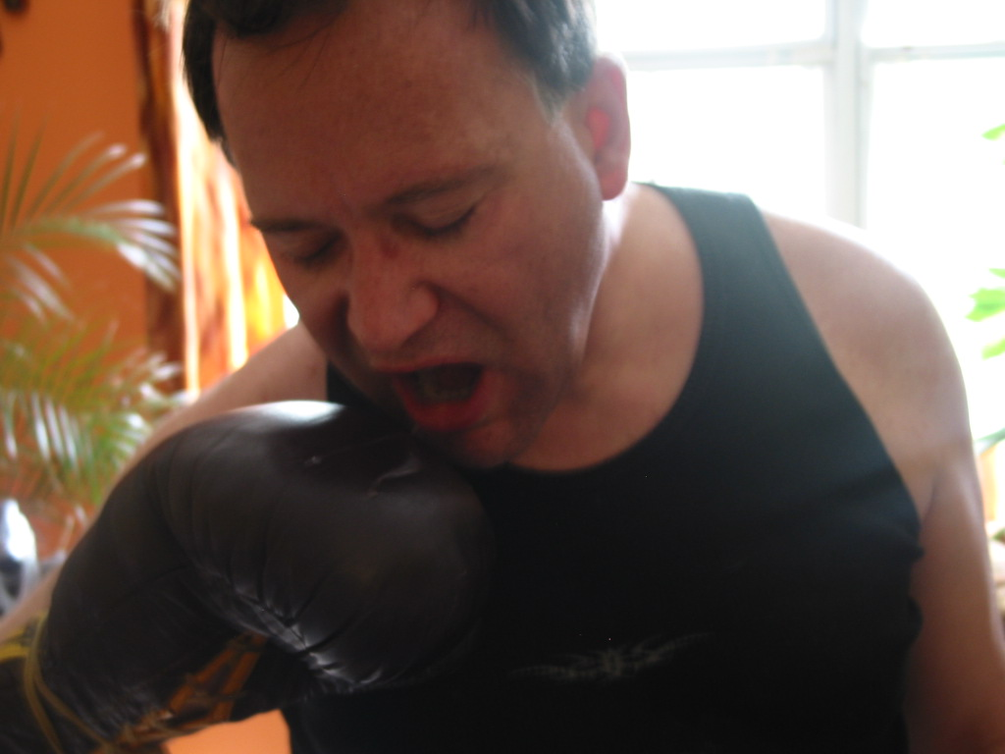
The cum was still white – it was fresh. He started licking quickly to savor every last drop of his own man cream.

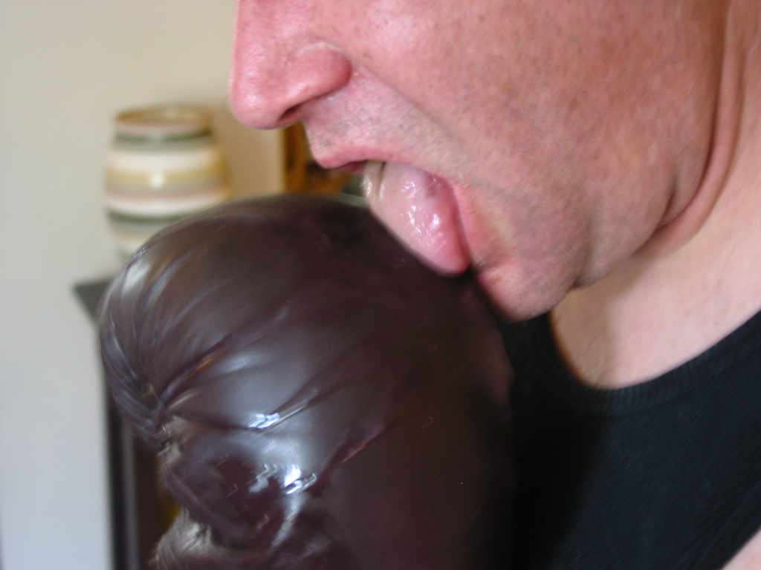

The aroma of fresh cum his nose and sent him off dizzily, like he had been hit by a hard right hook. Licking into each nook and cranny of his boxing gloves sent visions of cleaning pussy – though not quite as exciting. Yet the taste of his own cum again blurred his mind of images except strokes of lightening in a pitch black night. Every time he swallowed his man cream, his stomach was hit by a wave of power. He would involuntarily contract his abdomen as each drop of cum hit his gut.

Like before, waves of power streamed out with each taste of his own cum. Power streamed out to his boxing gloved fists. Power streamed down to his now limp manmuscle. When Stan was finished licking up his second course of the Breakfast of Champions, the power in his fists caused him to raise his arms and again flex his mighty arms. He puffed up his chest and flexed. By now his dick was filling up again, too. His balls were as big as ever.

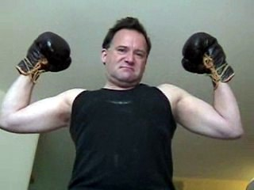



Banging his boxing gloves fists together, Stan flexed his arms and his canon, sneering, “Play hard to stay hard!” It was time for his third helping …

