Stan Cum KO’s G4

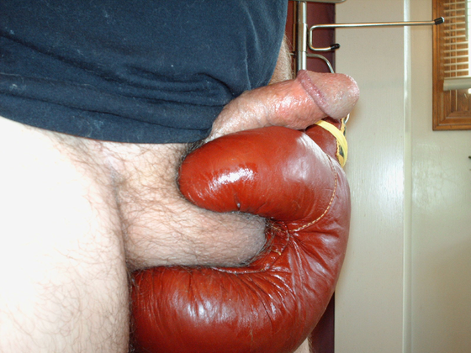

My BALLs are Loaded. Gonna PLAY HARD to STAY HARD. Now make my MANMUSCLE HARD. Nothing like LEATHER BOXING GLOVES to
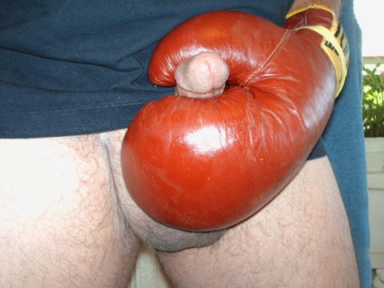

get my MANMUSCLE Raging HARD. YEA STROKE it HARD.

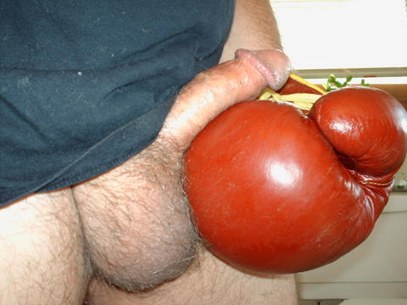

Get ready for my CUM KO.

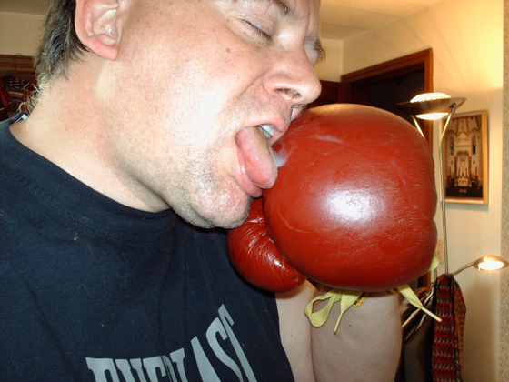

I left enough for you, OK?

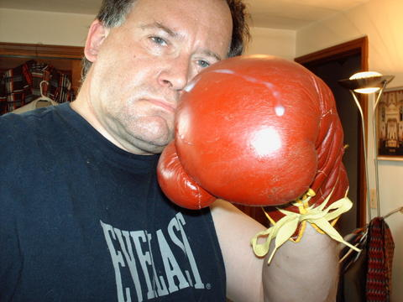

Taste of CUM makes my MUSCLES BIG AND HARD
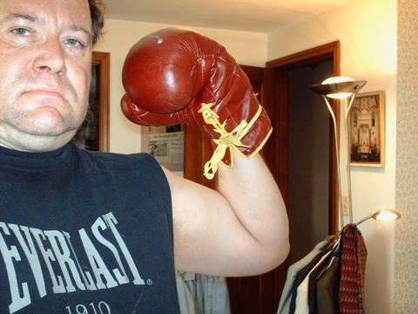

So I can DELIVER A KNOCK OUT PUNCH
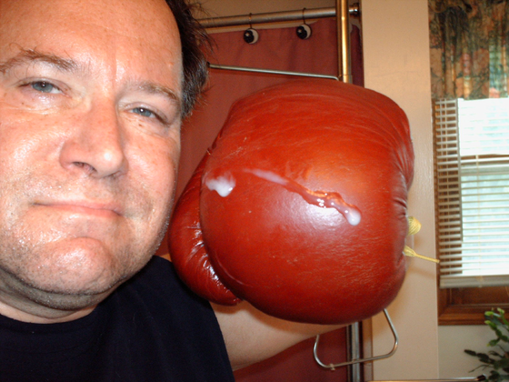

Right to your FACE, G4 – get ready to be KO’d
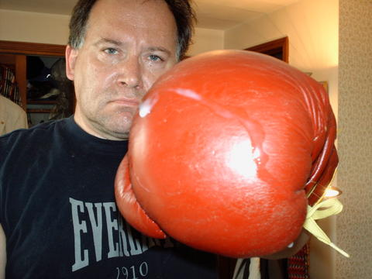

FEEL STAN’s POWER!!!!!

